Extension of Containerized E-Commerce Microservices Backend

Jun Tang - 2111172

1. Introduction
This project is an extension of the midterm microservices-based e-commerce backend system. The original system consisted of independently deployed services for handling products, customers, and orders.
In this deliverable, the system was enhanced to improve architecture, scalability, and maintainability by introducing:
- Asynchronous messaging using RabbitMQ
- An API Gateway (Ocelot) as a unified entry point
- DTO-based data transfer to reduce coupling
Improvements from Midterm
Compared to the midterm version, the following improvements were made:
- Added a fourth service: Payment Service
- Introduced event-driven communication between services
- Implemented API Gateway routing and aggregation
- Refactored services to use DTOs instead of exposing entities
- Improved system decoupling and scalability

2. Architecture Diagram
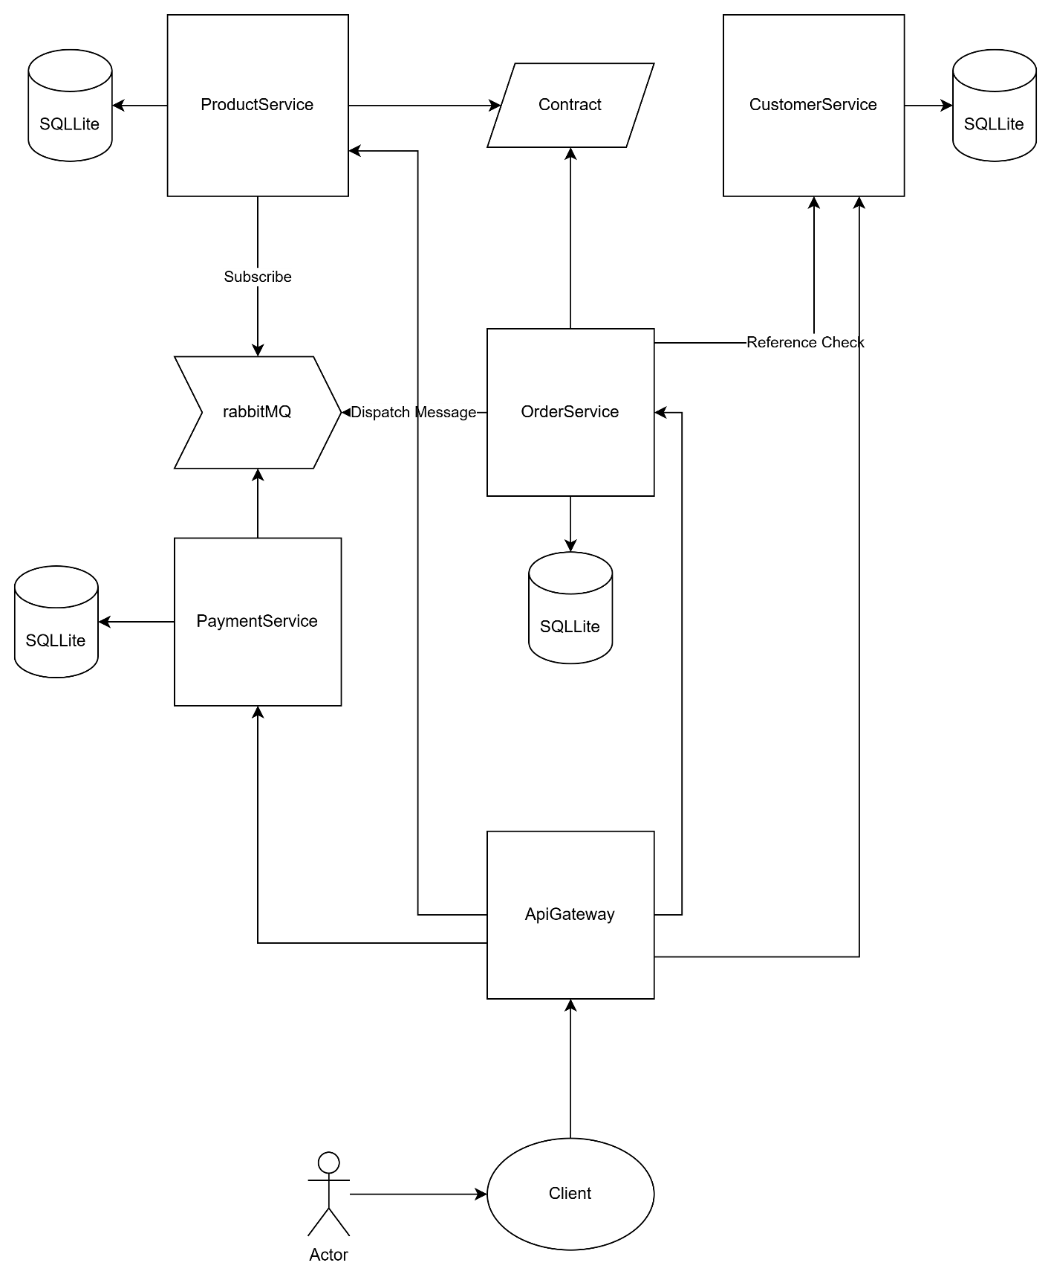

3. API Gateway Design
The API Gateway was implemented using Ocelot in ASP.NET Core.
Routing
The gateway acts as the single entry point for all client requests.
Clients no longer communicate directly with internal services.
Example routes:
Gateway Route | Downstream Service
/gateway/orders | Order Service
/gateway/products | Product Service
/gateway/customers | Customer Service
/gateway/payments | Payment Service
This ensures:
- Centralized access control
- Simplified client interaction
- Better scalability

Aggregation Endpoint
A custom aggregation endpoint was implemented:
GET /aggregates/orders
GET /aggregates/orders/{id}
This endpoint combines data from multiple services:
- Order Service → order data
- Customer Service → customer info
- Product Service → product info
- Payment Service → payment info
Example response:
{
"order": {...},
"customer": {...},
"product": {...},
"payment": {...}
}
Aggregation is implemented in the API Gateway using HttpClient to call multiple services and merge results.

4. Messaging Design (RabbitMQ)
RabbitMQ is used for asynchronous communication between services.
Events Used
- OrderCreated (core event)
- Additional event (e.g., StockUpdated or equivalent system reaction)
Producers
- Order Service
  - Publishes OrderCreated event
Consumers
- Product Service
  - Consumes event
  - Updates product stock
- Payment Service
  - Consumes event
  - Creates payment record
  - Calculates payment amount

Message Flow
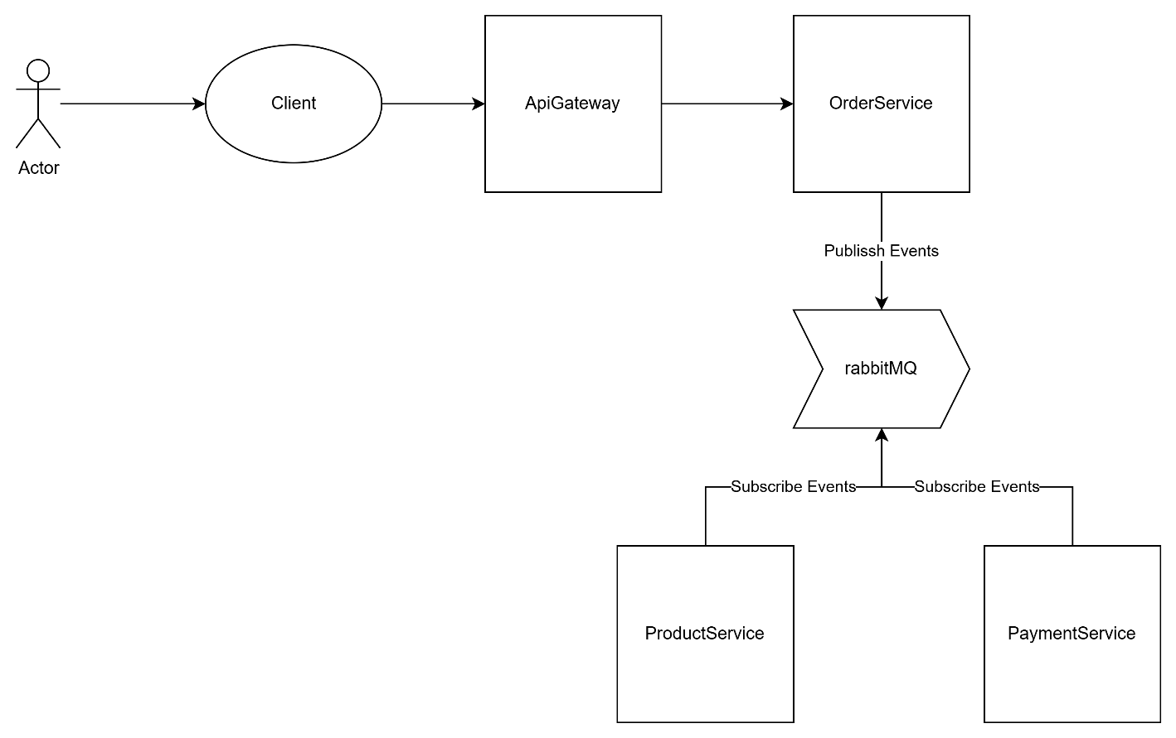

Behavior
- Product Service reduces stock when an order is created
- Payment Service calculates amount and records payment
- Services are loosely coupled and do not directly depend on each other

5. DTO Design
Purpose
DTOs (Data Transfer Objects) are used to:
- Avoid exposing internal domain entities
- Reduce coupling between services
- Improve API clarity and security

Example
Before (Midterm)
public class Product
{
public int Id;
public string Name;
public decimal Price;
}
After (DTO-based)
public class ProductResponse
{
public int Id { get; set; }
public string Name { get; set; }
public decimal Price { get; set; }
}

Usage
- Controllers return DTOs instead of entities
- Input models also use DTOs
- Mapping is done manually in services

6. Challenges & Solutions
1. Payment amount always 0
Problem:
Order events did not include price information.
Solution:
Payment Service retrieves product price from Product Service and calculates:
Amount = Price × Quantity

2. API Gateway aggregation returning 404
Problem:
Ocelot intercepted /aggregates routes.
Solution:
Used MapWhen in Program.cs to route aggregation requests to controllers before Ocelot.

3. bin/obj files being committed
Problem:
.gitignore was added after files were tracked.
Solution:
Used:
git rm -r --cached .
git add .

4. RabbitMQ message consumption issue
Problem:
Multiple services shared one queue.
Solution:
Switched to:
- Exchange (fanout)
- Separate queues per service

7. Docker & Deployment
The system is fully containerized using Docker.
docker-compose includes:
- Product Service
- Customer Service
- Order Service
- Payment Service
- API Gateway
- RabbitMQ
System runs using:
docker compose up --build

Key Design
- Each service runs independently
- Internal services are NOT exposed externally
- Only API Gateway is exposed

8. Conclusion
This project successfully extends the original microservices system by introducing:
- Asynchronous event-driven communication
- Centralized API Gateway architecture
- DTO-based data handling
The system is now:
- More scalable
- More maintainable
- Loosely coupled
- Closer to real-world microservices architecture

